Maps of level 6 - Cal
The city of Cal has a circular shape and is surrounded by walls. Functionally it is divided into four quadrants, they are: the castle to the north-east, the port to the southeast, the market to the northwest, and the boroughs to the southwest. The sewers run underground.
Picture 1: City map
Legend
█Market | █Pavement | █Street | █Water
█Quest | █Building | █Wall | █Green

Castle
The castle, among many things, is provided with prisons.
Picture 2: Map of the castle

Prison
The prisons in which the rebels are captured and where Luffy will also be imprisoned.
Picture 3: Map of the prison

Port
The port overlooks the river.
Picture 4: Map of the port

Market
In the market area, there are the police barracks, and the alchemist's guild.
Picture 5: Map of the market

Barrack
The police barracks where the dragon ball will be stolen.
Picture 6: Map of the barrack

Guild
The alchemist's guild.
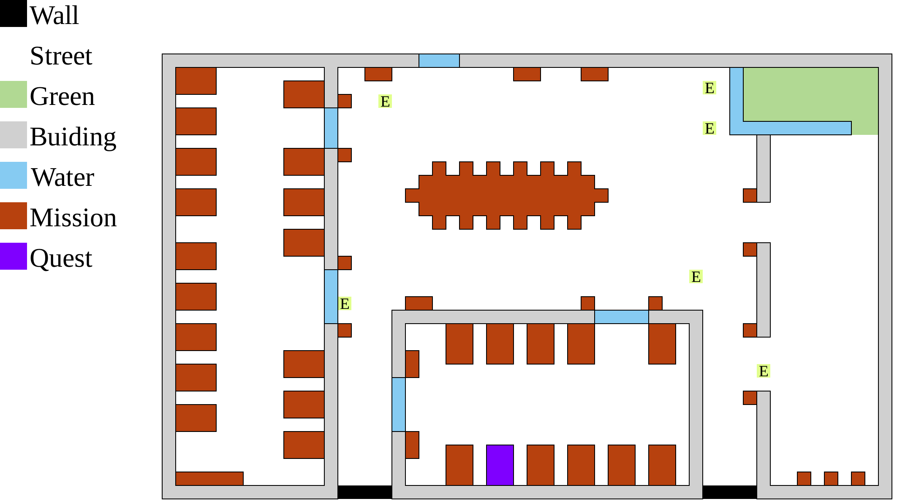Picture 7: Map of the guild

Boroughs
In the boroughs area we find the base of the rebels and the tavern where they meet. From the diagram on the left the map on the right has been obtained.
Picture 8: Sketch of the boroughs | 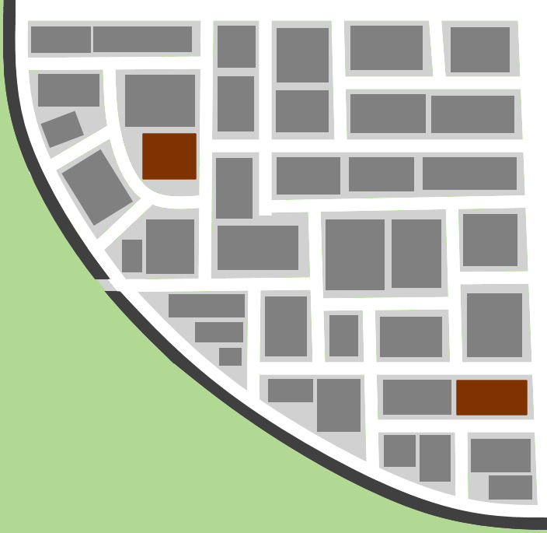Picture 9: Map of the boroughs

Base
In the base our heroes can interact with the rebels, the dialogues can be found in the chapter “Script of level 6 Cal”
Picture 10: Map of the base

Tavern
In the tavern our heroes can interact with the rebels, the dialogues can be found in the chapter “Script of level 6 Cal”.
Picture 11: Map of the tavern.

Sewers
The sewers smell.
Picture 12: Map of the sewers

